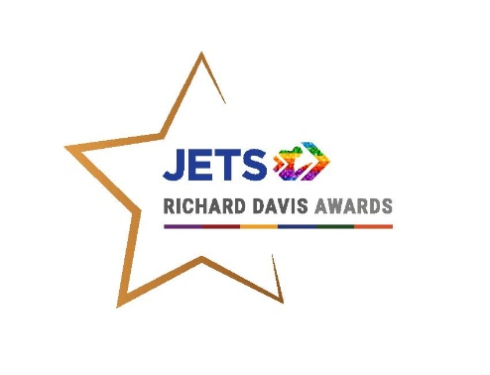 

**Richard Davis Awards Entry Form - The BHA Development Award**

**Awards Background**

The JETS Richard Davis Awards, now in their 27th year recognise and reward the career development of jockeys, past and present. The Awards aim to highlight some of the best examples of jockeys’ career development and encourage and inspire others to do the same.

The Awards have been running since 1997 and are named in memory of Richard Davis who had begun planning his second career when he was tragically killed in a race fall in 1996.

**The Awards are split into 3 categories:**

* **The Jockey Club Achievement Award** (for those who have shown significant achievement in an established business or second career) - £3,000 to the winner, £500 each to the two runners-up
* **The IJF Progress Award**  (for those that have started out or started working towards a second career in the past two years and have shown good progress) - £2,000 to the winner
* **The BHA Development Award**  (Exclusively for currently licensed jockeys who have shown real commitment to their career and personal development, both in and out of the saddle, demonstrating ways in which they have proactively worked towards maximising their career as a jockey and preparing for their second career) - £1,000 to the winner

**N.B. Entries for this Award can be submitted by the Jockey Coach.**

**Submission Details and Deadline:** Applications should be emailed to Phil Kinsella [phil@jets-uk.org](mailto:phil@jets-uk.org) by Friday 6th September 2024. The Awards will take place at Warwick Racecourse on November 5th and will be invited to the races with a guest as part of their prize.

**BHA Development Award – Entry Form**

1. **Personal Details**

|  |
| --- |
| Name: |
| DOB: |
| Address: |
| Email: |
| Phone: Mobile: |

1. **Riding Career**

|  |
| --- |
| FIRST LICENSED: |
| CAREER SUMMARY (Licence(s) Held/Rides/Wins/Big Race Wins): |

1. **Please state any contact you’ve had with JETS** (**Y**es/**N**o– please delete)

|  |  |
| --- | --- |
| **JETS Support** | **Yes/No** |
| Initial Consultation | **Y/N** |
| Training Advice | **Y/N** |
| Career Guidance | **Y/N** |
| CV Preparation | **Y/N** |
| General Job Search Assistance | **Y/N** |
| Interview Technique Training | **Y/N** |
| Recruitment/Work Placement | **Y/N** |
| Personal Development Plan | **Y/N** |
| * 1. Training Courses (please specify name and date): | **Y/N** |

1. **Video Entry – Please submit a video covering and development you have made in the areas highlighted below. The video should be no longer than 5 minutes in length. For guidance on submitting your video entry** [**CLICK HERE**](https://youtu.be/pEFKR2l9sYU)

**Jockey Coach** - How often are you in touch with your jockey coach? What type of coaching do you receive? What areas have improved as a result of having a coach?

**Wider Support Network e.g. Nutrition, Strength and Conditioning, Sports Psychology**  – How have you engaged with any of these services? What improvements have you noticed?

**Personal Development Plan** - Have you achieved any career goals or targets you set out in your PDP? If so, please provide details.

**Training** **& Qualifications** - Have you used JETS to do any training? Are you working towards any qualifications? E.g. Level 3 Racehorse Care and Management. How has this helped you and how might you use this in the future?

**Other Information** - Is there anything else you have done which you would like the judges to consider in your application? E.g. Hobbies, charity work, other general achievements you’re proud of in your life.

N.B. We recognise the broad and individual nature of Personal Development so speak to Lisa or Phil if you’re unsure whether your efforts qualify. Where applicable, make links to how the activity or achievement fits in with your current and future personal development / career aspirations.

You may wish to include references, or personal reflections on the impact that engaging in personal development activities has had on yourself and others. **If there are any details of your application that you would like to remain confidential, then please let Phil know.**

**Terms and Conditions:**

* Entries must be received by Friday 6th September 2024
* A shortlist of three finalists will be selected from the entries
* The winner receives a prize of £1,000 and hospitality for two at the races.
* The judges’ decision is final
* By entering these Awards you agree to taking part in publicity for JETS, The Injured Jockeys Fund and the Richard Davis Awards

I agree to the above Terms and Conditions.

Signed: Date:

PLEASE EMAIL THIS COMPLETED FORM TO PHIL KINSELLA: [phil@jets-uk.org](mailto:phil@jets-uk.org)

VIDEO SUBMISSIONS FOR SECTION 4 CAN BE SENT VIA WETRANSFER OR TO PHIL (07970 673351) VIA WHATSAPP OR MAILDROP .